Machine Problem 2

ORG 000

INPUT

STORE A

WHILE, LOAD X

SUBT A

SKIPCOND 000

JUMP END

JUMP IF

END, HALT

IF, LOAD X

SKIPCOND 400

JUMP ELSEIF

JUMP IFLOOP

IFLOOP, LOAD A

OUTPUT A

LOAD X

ADD ONE

STORE X

OUTPUT X

JUMP CHECKIF

CHECKIF, LOAD X

SUBT A

SKIPCOND 000

JUMP END

JUMP ELSEIF

ELSEIF, LOAD FOUR

SUBT X

SKIPCOND 800

JUMP ELSE

JUMP ELSEIFLOOP

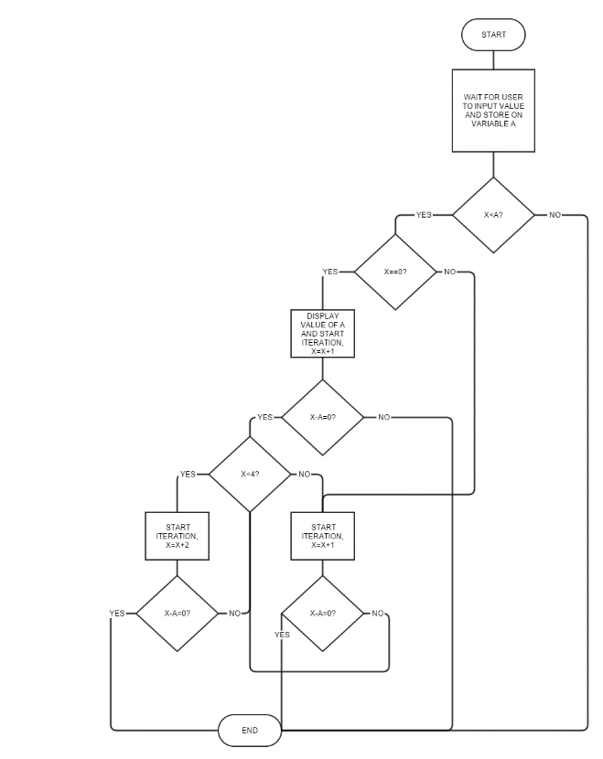

ELSEIFLOOP, LOAD X

ADD TWO

STORE X

OUTPUT X

JUMP CHECKELSEIF

CHECKELSEIF, LOAD X

SUBT A

SKIPCOND 000

JUMP END

JUMP ELSEIF

ELSE, LOAD X

OUTPUT X

JUMP ELSELOOP

ELSELOOP, LOAD X

ADD ONE

STORE X

OUTPUT X

JUMP CHECKELSE

CHECKELSE, LOAD X

SUBT A

SKIPCOND 000

JUMP END

JUMP ELSELOOP

A, DEC 00

X, DEC 00

ONE, DEC 01

TWO, DEC 02

FOUR, DEC 04